OUR SERVICES>ANNOTATION SERVICES
DATA ANNOTATION SERVICES
- Introduction
DIGITAL NEST SOLUTIONS specializes in in all types of Data Annotation services.
We have the expertise, processes and a human-in-the-loop platform to meet the challenging AI projects and we do it all within your timeframe and budget.
WHAT WE OFFER
- IMAGE ANNOTATION
Image annotation can be understood as the process of labeling images to outline the target characteristics of your data on a human level. The result is then used to train a model and, depending on the quality of your data, achieve the desired level of accuracy in computer vision tasks
                - Image Classification
Our experts process the AI job more accurate than machines. Assigning a label or class to an entire image and expected to have only one class for each image. Our expert team can process within a period to meet the daily task.
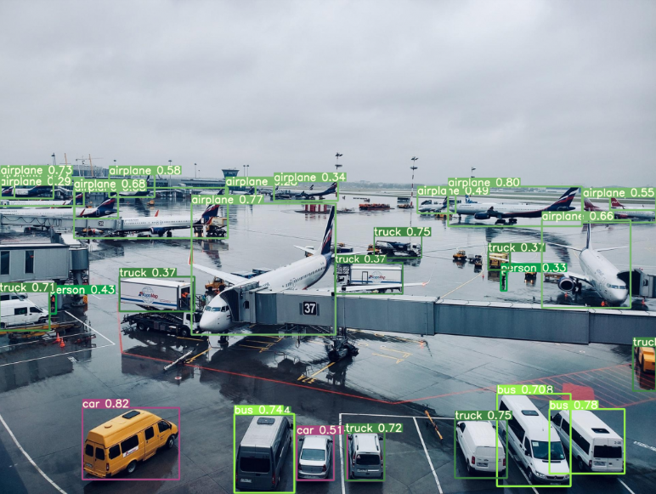 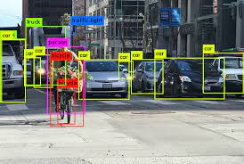
                - Semantic Segmentation
A deep learning algorithm that associates a label or category with every pixel in an image. Each workflow is outlined to gurantee quality over each pixel of given picture
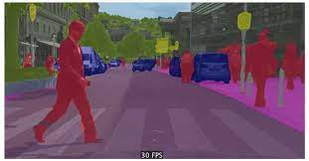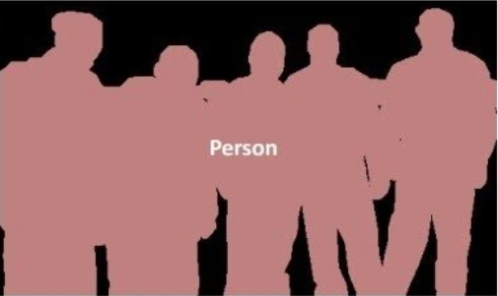

                - Instance segmentation
identifies the presence, location, number, and size or shape of the objects within an image. Therefore, instance segmentation helps to label every single object’s presence within an image
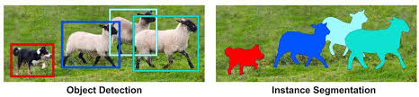
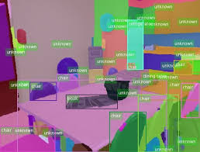
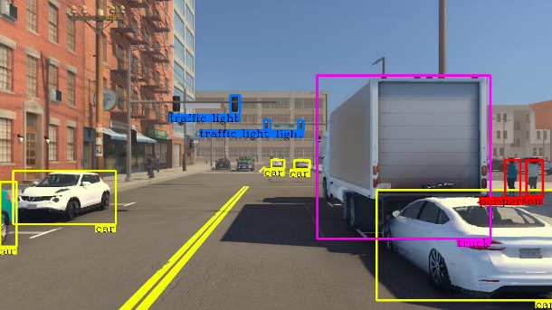
                - Object Detection
Object recognition/detection is a further version of image classification. It is the correct description of the numbers and exact positions of entities in the image. While a label assigned to the entire image in image classification, object recognition labels entities separately.
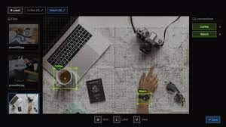
- VIDEO ANNOTATION
Responsibility for adding labels and tags to video footage. Unlike image annotation, video annotation involves annotating objects on a frame-by-frame basis to make them recognizable for machine learning models
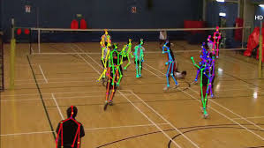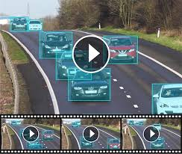

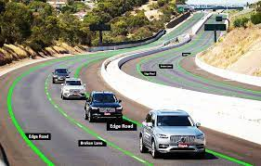
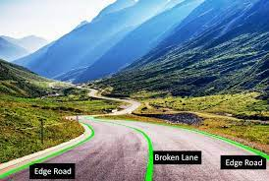
POLYLINE ANNOTATION
Polylines comment is reasonable in path location for independent vehicles characterizing bike, bearings, disparity and inverse course activity to see the environment for
secure and trouble-free driving of such vehicles supported with fruitful AI-models
Provides
1. Detect Lanes for Self-driving Vehicles
2. Accurate Lane detection with polylines
3. Precise Lane detection with analytics

- KEYPOINT ANNOTATION
Keypoint annotation is a more detailed protocol for image annotation used to detect small objects and shape changes by marking keypoint locations. Keypoint annotation is used to mark a single pixel in an image to represent the shape of an object. The purpose of image annotation is to assign relevant, task-specific labels to images so that they can be easily understood by AI.
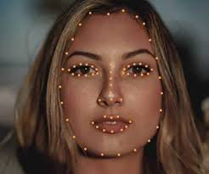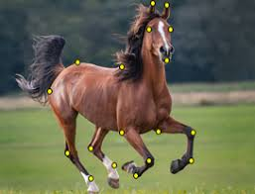

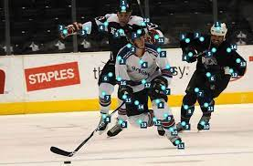
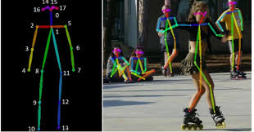
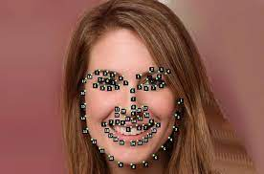
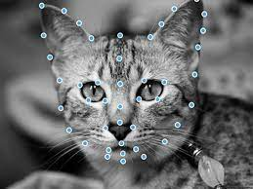
LANDMARK ANNOTATION
Landmarking is one of the important processes used in research to help machines recognize objects in their computer environment. Point of interest explanation frequently known as dab comment or posture estimation, creates points/dots all through an picture
a. Landmarking for Facial Gesture Recognition
Name with the key focuses at indicated areas to decide the signal or facial acknowledgment applications. It is primarily utilized for tallying applications utilizing the point of interest focuses explanation to discover the genuine thickness of the protest inside a specific region. It makes a difference to superior get it the development direction of each point movement within the focused on protest.
b. Annotation for Sports Analytics of Human Poses
Not as it were recognizing human facial expressions and feelings, picture point of interest comment is additionally utilized to distinguish the human figures and appraise their postures with right precision. Machine or computer vision can degree the pose of games in gather or person sports individual performing an activity whereas playing a diversion on the field.

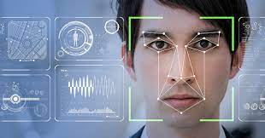
C . Landmarking with Anolytics for Better Accuracy
Presently prepare your machine distinguish human figures and assess human postures in 2D pictures and recordings. Separated from facial acknowledgment, utilized for opinion investigation and forecast of the person on foot movement for the independent vehicles. Anolytics is competent to convert the crude information into points of interest on the objects of intrigued with best exactness.
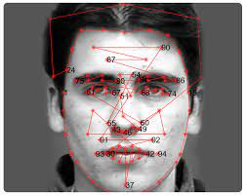
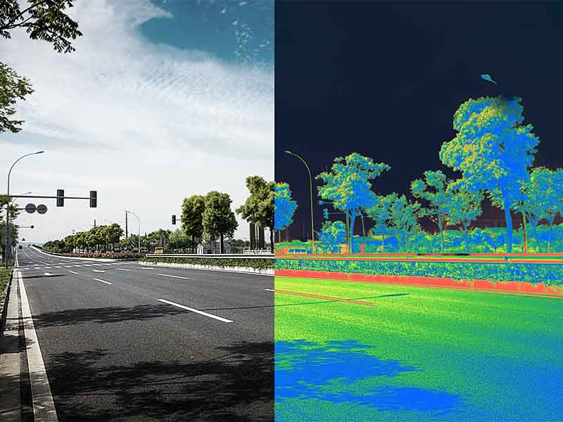
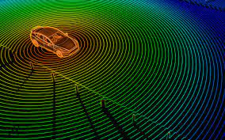
- LIDAR ANNOTATION
Lidar (Light Location & Extending) information is a basic sensor for geospatial innovation, independent innovation, and numerous other industry applications. Lidar utilizes lasers, scanners, and specialized GPS recipients to calculate separations to a given protest. Explaining Lidar information could be a challenging and time-consuming errand that requests an expert-level understanding of information comment. Lidar comment can be combined with picture explanation to prepare computer vision and other profound learning models to perform an assortment of assignments.
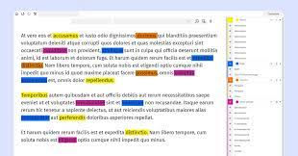
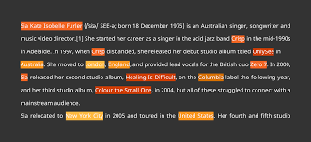
- TEXT ANNOTATION
Content comment makes a difference machine learning models get it content information. Common workflows that utilize content explanation incorporate estimation and aim investigation, part-of-speech labeling, substance acknowledgment and classification. Amid the content comment prepare, the information is parsed into the specified categories counting expressions, sentences, and watchwords, based on the rules of the venture. The explained datasets train machines to communicate proficiently within the normal dialect of people.


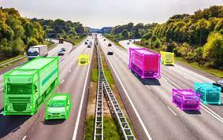
- 3D CUBOIDS ANNOTATION
Cuboid annotation is the assignment of labeling objects in 2D pictures with cuboids. The 3D cuboids offer assistance to decide the profundity of the focused on objects such as vehicles, people, buildings, etc.
Examples of AI
INTENT AND SENTIMENT ANALYSIS
Aim examination could be a step ahead of sentiment investigation. Whereas the last mentioned may be a common content classification instrument that investigations an approaching message and tells whether the basic assumption is positive, negative, or unbiased, expectation investigation tells you all almost the user's purposeful behind the message.
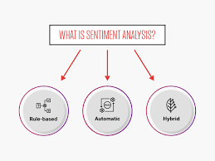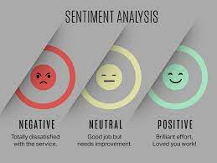
- LAYER ANNOTATION
Couldn’t able to find only layer annotation

- What we have done so far
Provided
Where we serve
Across the world

